|  |
| --- |
| Business Model |
| This document consists of the information about the ways I (Taloshili Nghiwewelekwa will make money in the coming future |
|  |
|  |

Table of Contents

Introduction 1

Summary 1

Overview 1

Concepts 1

Resource 1

Audience 2

Micro games 2

Process 2

Realistic 3

Skills 4

Video editing 4

Timeline 4

January to April 4

May to August 5

September to December 5

Game Experience 5

User interface 5

UX design 5

Controls 5

Menus 5

Design I 5

Diegetic menus 5

Visual and audio bible 5

Market requirements 5

Minimum Viable Product 5

Stretch Goals 6

Work Packages 6

Base prototype 6

Gameplay pass 6

Media pass and play test 6

Battle Pass 6

Second Playtest and story elements 6

Final feature pass 6

Polish pass 6

Demo Pass 6

Release Pass 6

Extra Pass 6

# Introduction

## Background of the study

This document consists of information about the Optin Page, which is a website used to collect essential information from users who happen to be interested in a specific product. Essentially, the website requests the users for their email and informs them that they will be receiving news articles.

# Statement of the problem

The main issue here is that

# Literature Review

## Introduction

A

## General Description of the Optin Page

A

## Types of Optin Pages

These

## Similar to existing pages

These

## Meaning of Optin Page

These

## Contribution as a sale

These

## Process Mode

These

## Software Model / Design and methods

These

# Design and analysis of the system

Firstly,

## Software development stages

These

## Software development models

These

## Use Case Map

These

# Application Organization

This is one of the comments that I saw on Thomas Brush video, which serves as a reality check on how realistic this plan should be in execution:

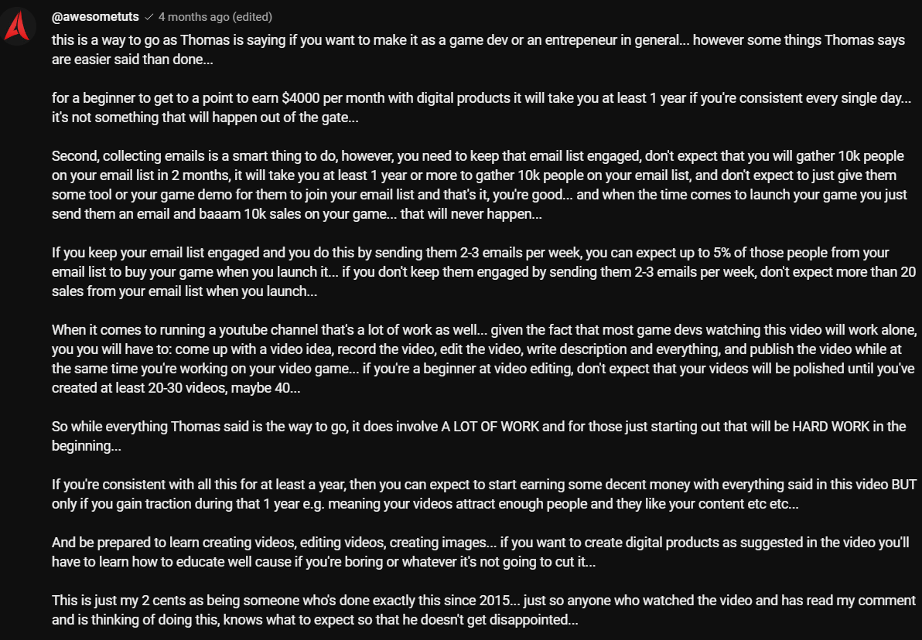

This is where the vanity metrics should be considered. When you successfully collected the people’s emails, do you think all those people would translate to the amount of sales the game? Do you think all those 4000 people who gave you their email 2 years ago, will translate to game you are planning to release? The answer is no. What needs to be done is simple, but not easy. Keep those people engaged. Now the question is, what will you use to keep them engaged? How long will it take for you to be sure that these emails will translate to sales?

# Skills

There are a lot of skills that you need to take into account. Here are a few:

## Video editing

This is one of the most crucial skills to have. Videos with good editing will take you so far; couple with the kind of content you make. For me right now, all I can do is cut out parts of a video, transition, and all those basic things. They aren’t particularly entertaining so I’ll have to work on that. My inspirations in video editing are the following individuals:

* Volksgeist

The colour that this individual has when he releases his video is something that I truly admire. His documentary style videos are the ones that I really enjoy. Whenever he plays an audio, I like how the audio wave shows up.

* Regal State

This individual is sort of the same as the first one.

* Venom edits

The venom edits are one that I should really try doing as it does have a number of techniques I can learn from

## 3D modelling

This skill is probably one of the most important skills in game development. 3d modelling in game development would really assist in making assets for your game. Not just assets for the game, you will be able to make full character for scenes that you want to work with. The only thing that I need to know is what is the difference between the assets used in game development and assets used in making animations? Are they the same or is there a difference? I have to learn the standards of how to make these 3d models. For now I am still at the introduction of 3D modelling. What I’ve learned for now is:

Basic 3D modelling

Sculpting

Shading

There are many way for me to do this, however it’s always good to follow a roadmap. This is from a reddit user who mentioned it in clear detail on how you can learn a tool such as blender:

Do beginners tutorials. I cannot stress this enough. Not only will this save you a great deal of time and frustration, but probably from rage quitting as well. Even if they don’t teach you the specific thing that you want to do, after doing the beginners tutorials you will at least have a feel for the program, understand the basic navigation controls and have the vocabulary as you ask the right questions. Make notes as you go, particularly of hot keys

Repeat the tutorials from memory. Makes notes on the bits that didn’t stick the first time that you have to look up. This is the challenge, how much can you remember.

Now make something similar, but not the same. Similar is that you don’t need tools you haven’t learned yet but not the same so you have to start making your own choices. Instead of a donut, make a cupcake or something else. This is what forces you to not just get stuck with the tutorials

Move on to the next tutorial. Give each one your best shot and move on. These are learning exercises, sketches, not finished masterpieces, don’t get stuck obsessing over it at this stage as repetition of the basics is the key and you won’t get to do that by spending hours obsessing over one setting. Save it for later.

Doodle. Spend a paart of your allocated daily time with blender just messing about what you know so far. Don’t think about making a project that brings expecations with it you don’t need. Just doodle in 3D.

Ask questions. No one minds helping those who are making an effort. Tell us what you are doing, what you expected to happen, what did happen, what did you try and fix it. Post a screenshot and include the whole blender window a picture is work a thousand words.

Don’t get discouraged. Your ability to see what looks good will advance more quickly that your ability to actually do it. This should be expected. Also don’t compare yourself to others, the only measure of progress that counts is, do you know something today that you didn’t yesterday? Can you do something better today than you did yesterday? The rest is bullshit

## Animation

Animation is also one of the important skills to learn. Not just animation, but also rigging. All I need to learn is there are difference between regular animation rigging and game Dev rigging.

# Timeline

The year is divided into 3 trimesters:

## Phase 1

* January – April
* May – August
* September – December

## January to April

The first quarter months will consist of picking up 3d modelling skills. Among all the skills in game development, this one is quite important as there are a lot of concepts that you will need to be familiar with. Not only concepts, you will need to be able to apply these concepts when working with different meshes.

It is a valuable skillset as:

You can build whatever you want with the software of your choice. The only limitation would probably be technical as there is software that requires a lot of RAM to run. However, it could save the amount of money you might spend in the future if you want to buy assets. This is not to say that buying assets is completely out of the picture, you can use the knowledge of 3D modelling to manipulate assets that you may have bought so that they can be consistent within your game. Some of skills that you can have in 3D modelling are:   
3D Software Mastery: Proficiency in using the software of your choice to make these assets. It’s better to stick to just one software then to learn all of them as it will require time and consistency. I’ll stick to blender and learn all the different aspects according to what I am doing, without rushing.

Texturing and UV mapping: This is adding textures and mapping them onto models so these models can look realistic. This is also quite important as this can determine the kind of style your game possesses.

I will follow the blender roadmap for this quarter. To add also, in this quarter you must make the opt-in page. Make it as attractive as possible.

## May to August

Now that I learned the basics of 3D modelling and video editing, I can combine the 2 to make proper content for YouTube. What I was planning on making is having a jar of a bunch of objects, and then I pick from it what I should make. The way I want these videos to be is in a sort of Snapp makes beats kind of content where I will be making a blender model depending on what I get from the jar. This will also be the time where I will be making game assets.

## September to December

For this timeline, I release the opt-in page to collect emails for the game and keep them engaged with game assets resources.

# Game Dev Info

I do not really have a lot of information on game development in an industry sense. I just know some information on indie development. But for this section, it will cover the game development industry section. This information is from Masahiro Sakurai:

## [A: Work Ethic]

## [B: Game Essence]

## [C: Planning & Game Design]

## [D: Design Specifics]

## [E: Team Management]

## [F: Graphics]

## [G: Animation]

## [H: Effects]

## [I: Audio]

## [J: UI]

## [K: Programming & Tech]

### Name Files Logically

### Making your game easy to tune

### Put parameters in brackets

### Using tickets to manage tasks

### Family BASIC

## [L: Marketing]

## [N: Game Concepts]

# Why is this business model important

To Kick start The Guild. Despite this whole model about making profit from making games this is all done by one person. It cannot be sustainable. I would require a team. This team will consist of the following individuals:

1. Planner
2. Model and rig
3. Animation
4. Programmer
5. Effect designer
6. Sound designer
7. Play tester

